Level 4 – Graphical User Interface (GUI)

1. Description
We wrote a graphical user interface (GUI) in ASP.NET with C#.NET backend code.

For the interface, we used:
- The default layout with slightly modified CSS and a custom logo made in Photoshop.
- Gridviews for showing the table content and selecting rows, and DetailsViews for editing the row content and handling operations, all binded on SqlDataSources with select, insert, update and delete abilities. These may also be used to demonstrate constraints and triggers.
- Tables, Labels, Textboxes, DropdownLists, a Calendar and Buttons for the form showing the behavior of the function and procedure.

For the backend, we wrote very simple C# with straightforward functions for extremely quick development. This resulted in possible instability, vulnerability (there are two queries for which I have not cleaned the input, exposing us to XSS) and lack of extensibility and reusability.
The development was not very easy either (it took three days and quite a bit of headache) but it is relatively reliable, as far as we have tested.

2. Pictures of each screen
1. ~/Home.aspx
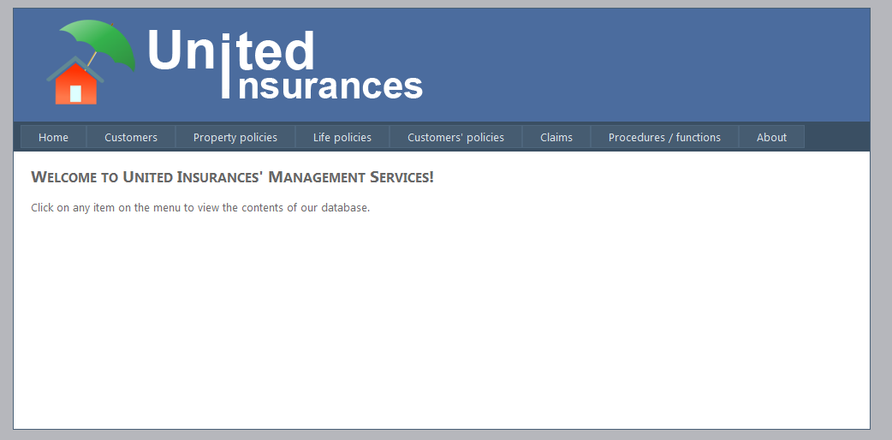

2. ~/Customers.aspx
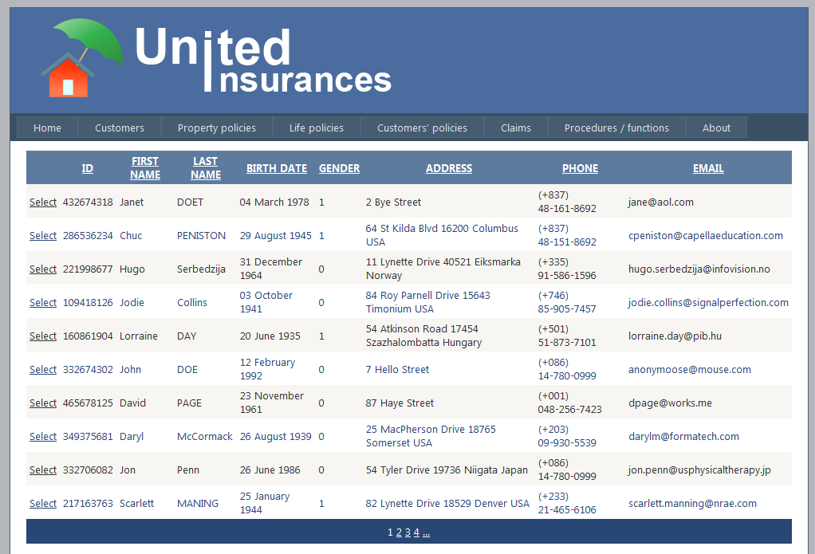

3. ~/PropertyPolicies.aspx
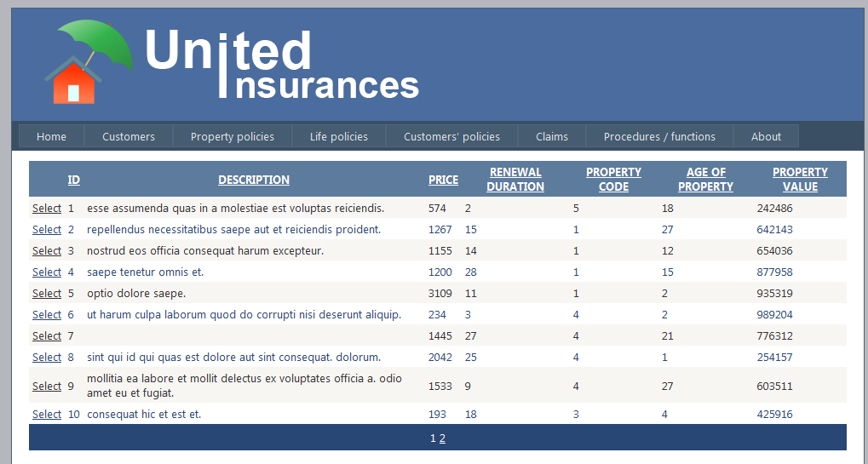

4. ~/LifePolicies.aspx
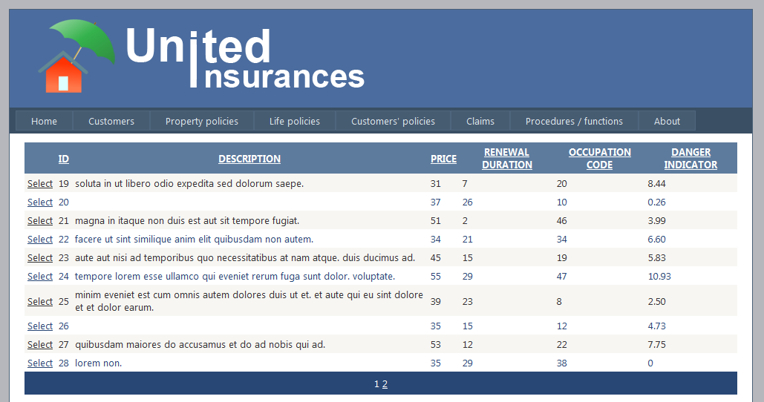

5. ~/CustomersPolicies.aspx
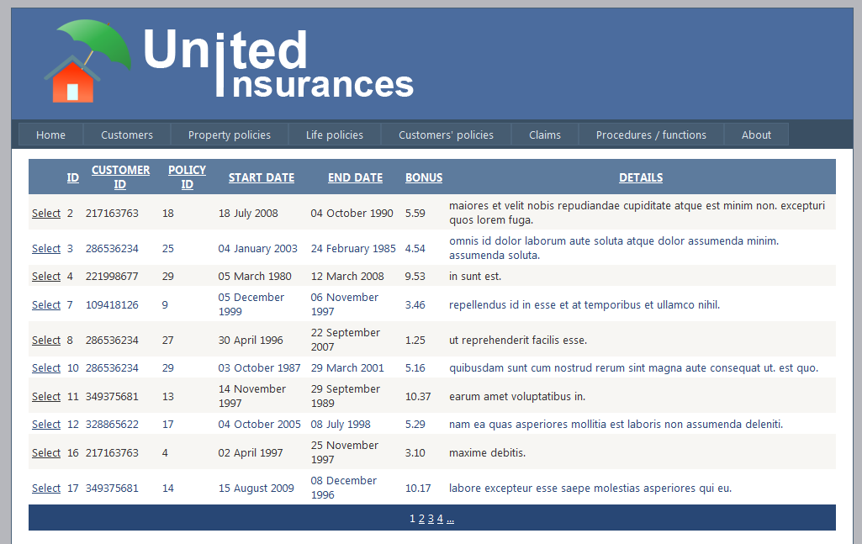

6. ~/Claims.aspx
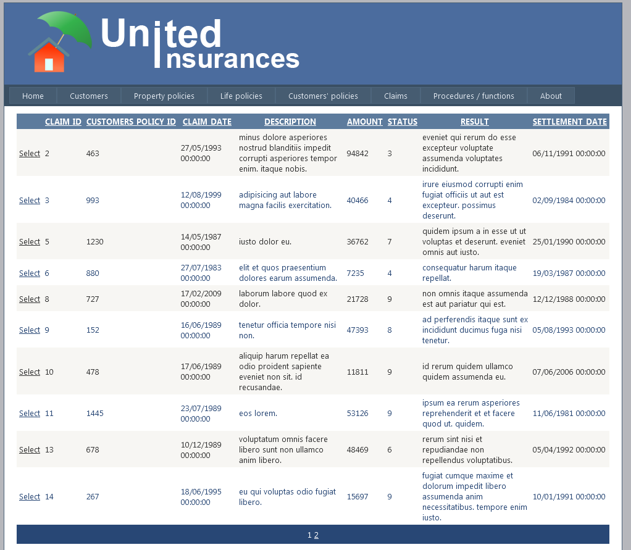
7. ~/Procfunc.aspx
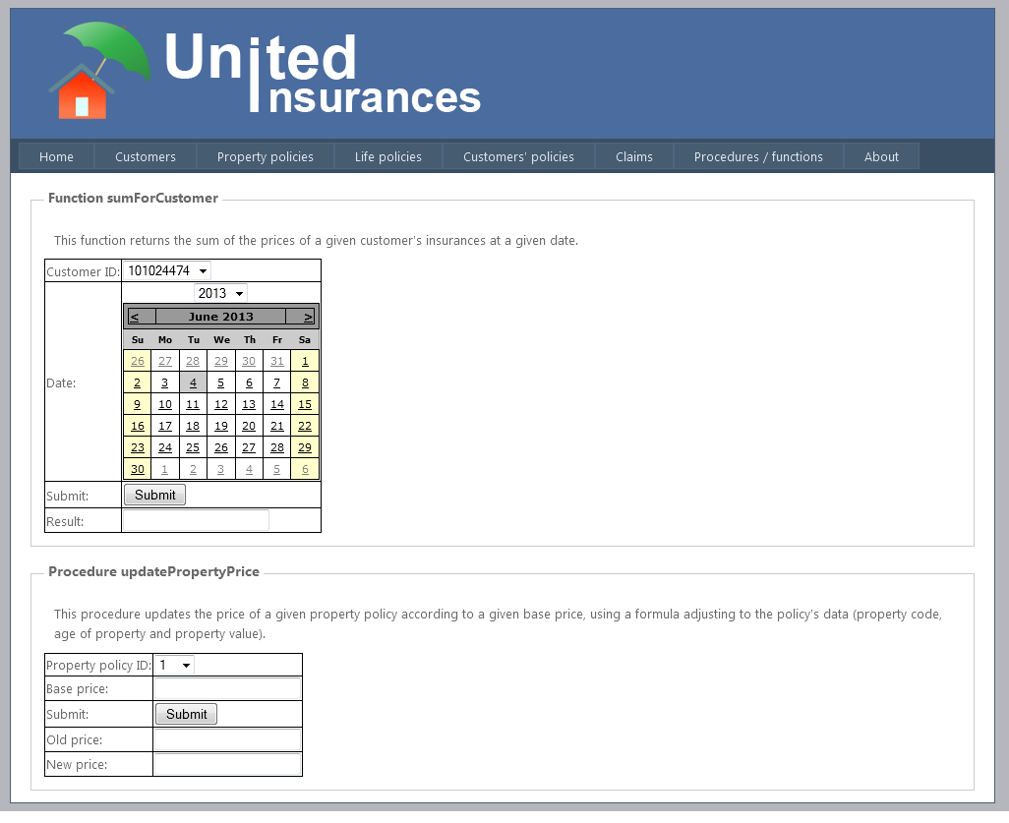

8. "~/About.aspx
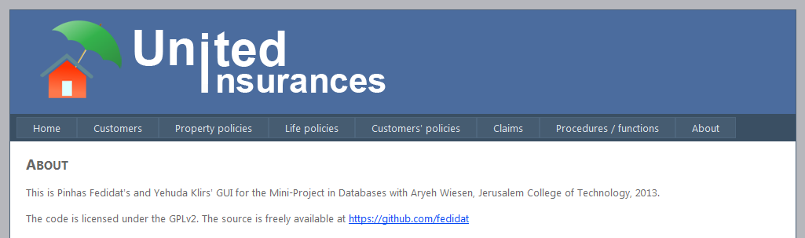

3. Demonstration
We will demonstrate the operations SELECT, INSERT, UPDATE, DELETE and the use of the procedure and of the function that we wrote in Level 3
1. SELECT
The page ~/PropertyPolicies.aspx shows the result of select * from policy natural join property
in its GridView (from the sqlDataSource it is binded to, named OraInsurance), as shown below:
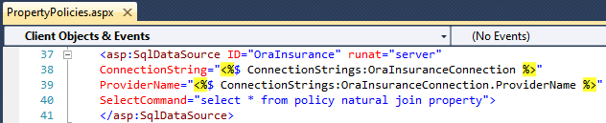
And here is the result on the webpage:
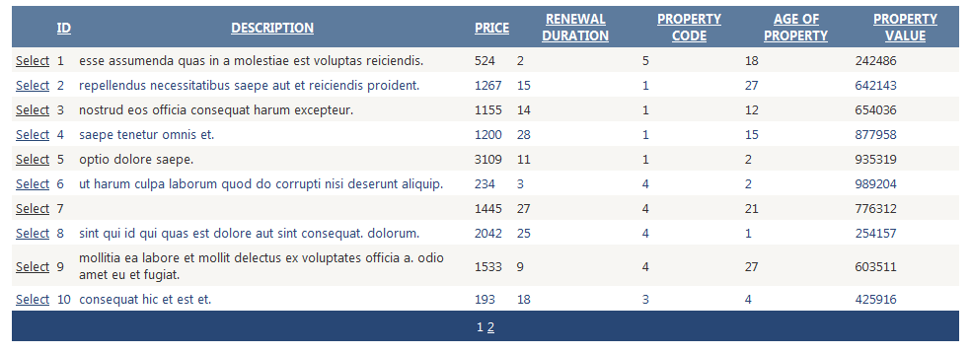

2. INSERT
On the page ~/Customers.aspx, we use the DetailsView with the Insert link/button to insert a new customer:
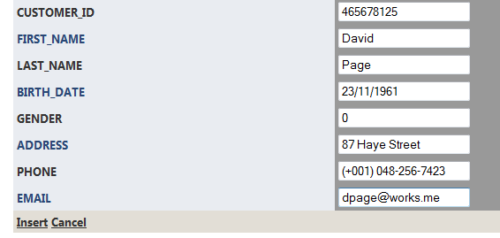
Then we press the Insert link/button and see the result in the table (the new customer is selected in the screen capture):
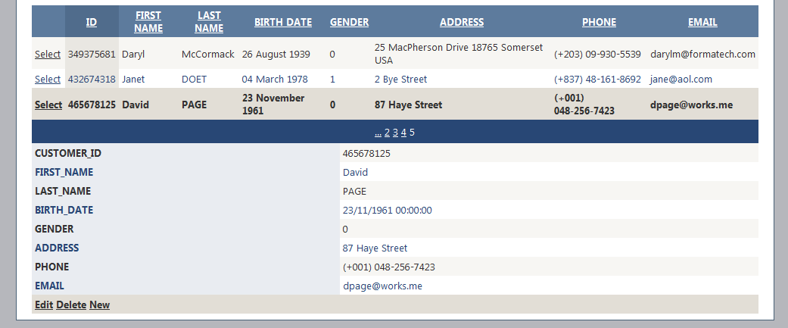
As expected.

3. UPDATE
Again on the page ~/Customers.aspx, we select customer ID 217163763:
Then we use the DetailsView with the Edit link/button to update Scarlett’s last name to Maning (in a real world scenario, perhaps this had been a typo that we are now fixing):
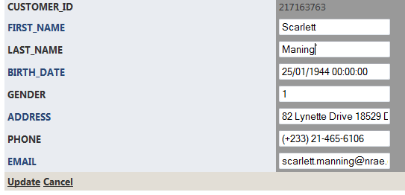
Then we click update and look at the updated record in the table:
Ah, you must have noticed that Scarlett’s last name has turned to uppercase. This is because of a trigger that we defined in Level 2, which turns the last name of customers on insert or update to uppercase. This is therefore very much expected.
4. DELETE
This time, on the page ~/Claims.aspx, we arbitrarily delete claim ID 4, which was applied on policy ID 1579, as we see on the picture below:
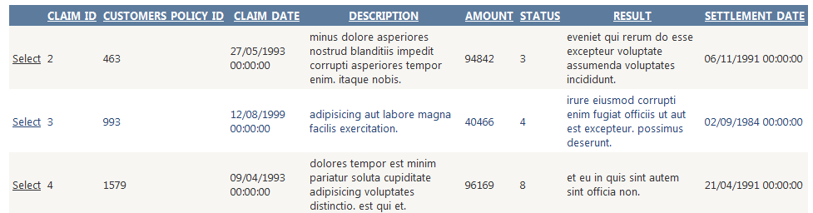
Let us select it and press the DELETE link/button:
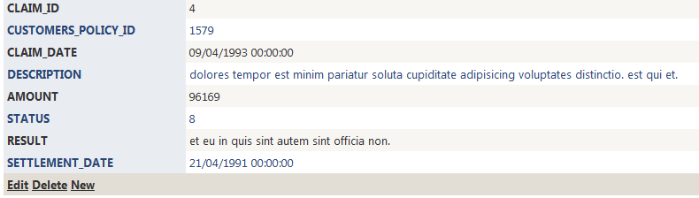
And it now nowhere to be found: when ordered by ascending ID, we see the table going from ID 2 to 3:
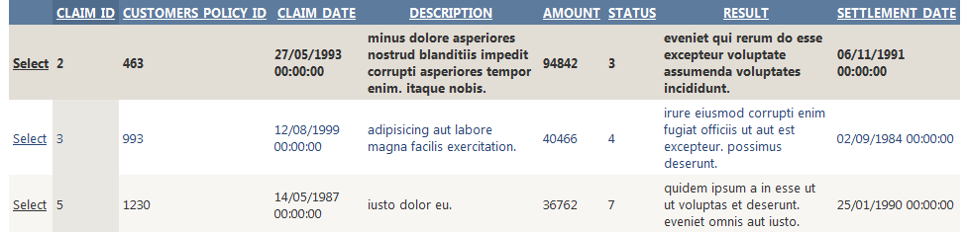
5. PROCEDURE
On the page ~/ProcFunc.aspx, we go to the “Procedure updatePropertyPrice” panel we arbitrarily select property policy ID 1 and enter 1000 as the base price for the new price of the selected policy.
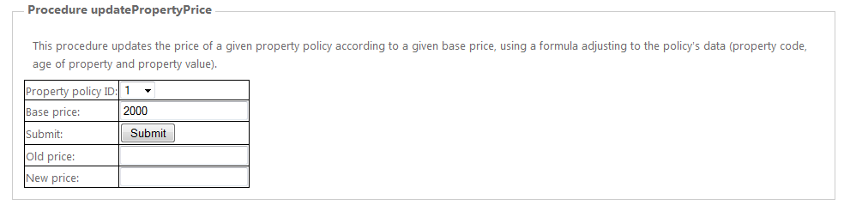
We now just have to press Submit and see the result:
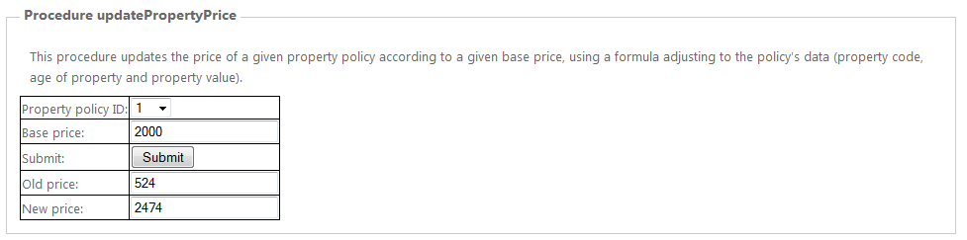

We can check in ~/PropertyPolicies.aspx that this is indeed true: below are the comparisons of before/after the procedure execution:

6. FUNCTION
Finally, again on the page ~/ProcFunc.aspx, we go to the “Function sumForCustomer” panel we choose to get the sum of policy prices for the customer ID 109418126, then on the DropdownList we select year 2006, the Calendar automatically moves to year 2006 (we implemented this because pressing 7 times the back arrow on the Calendar can be tiring), then we select May 1st, and finally we submit:
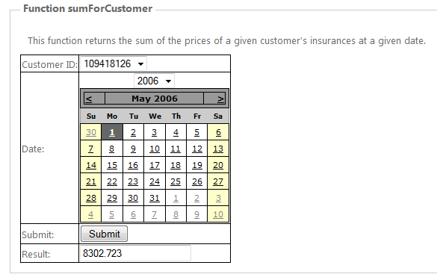
We have already proven the accuracy of this function in Level 2 and despite the fact that the policy prices have been modified since then, the function has not, and remains valid. We can therefore trust this result.
4. Conclusion
In retrospect, this project gave us the occasion to look at a lot of applications, methods and concepts:
- Model conception of RDBMS using DDS-Lite v2.21 with entities, relationships attributes, keys, normal form.
- SQL queries on an Oracle 11g express database with many types of operators.
- Writing views, indexes, commit/rollback, constraints, triggers, PL procedures, PL functions, PL programs and reports with substitution variables on PL/SQL developer v10.
- Connecting an Oracle database to a Java program from Netbeans or a C# program from Visual Studio 2010, as well as developing an ASP.NET GUI based on C# in a few days from very little knowledge.
On a personal note, this was also the first truly organized project for which we used a Control Versioning System (in this case, git, with a Github remote repository). At the time of writing, it is publically available on https://github.com/fedidat/Mini-project_in_Databases. All code written by us is licensed under the GPLv2.
We would like to thank Aryeh Wiesen for helping us along the way on the few occasions during which we struggled.

